**Team Firewall**

**2-Step Authentication Login**

**Use Case Report**

***Revision History***

|  |  |  |  |  |
| --- | --- | --- | --- | --- |
| **Authors** | **Description of Change** | **Sections** | **Rev** | **Date** |
| Team Firewall | Initial Release |  | 0 | 2/6/18 |
|  |  |  |  |  |

**Table of Contents**

**Team Description** **6**

**Project Description** **6**

Use Case Diagram 7

Use Case List 8

Create Account 8

Login 8

Edit Account Info 9

Change Username 9

Change Password 9

Change Email 9

Delete Account 9

Opt in/out of 2-step authentication 9

Do 2nd Level Authentication 10

Recover username or password 10

Allow server to remember username and password 10

Check 2-step credentials 11

Remember username and password 11

Check Login credentials 11

Send Email Confirmation 11

Store Information 12

Send 2-step confirmation code 12

# Team Description

|  |  |
| --- | --- |
| **Team Member Name** | **Email Address** |
| Gyromee Hatcher | gyromee@csu.fullerton.edu |
| Gaberiel Varela | gabrielv@csu.fullerton.edu |
| Ivan Rosales | irosales@csu.fullerton.edu |
| Mevin Chen | mevin.chen@csu.fullerton.edu |
| Meng-Shen Kuan | mengkuan@csu.fullerton.edu |
|  |  |

# Project Description

Statement of Purpose: Create a more secure login.

Detailed Description:

We will create a website and allow users to create accounts. From there they can login/logout, manage their account, and most importantly, opt in/out of 2-Step authentication for future logins.

## Use Case Diagram

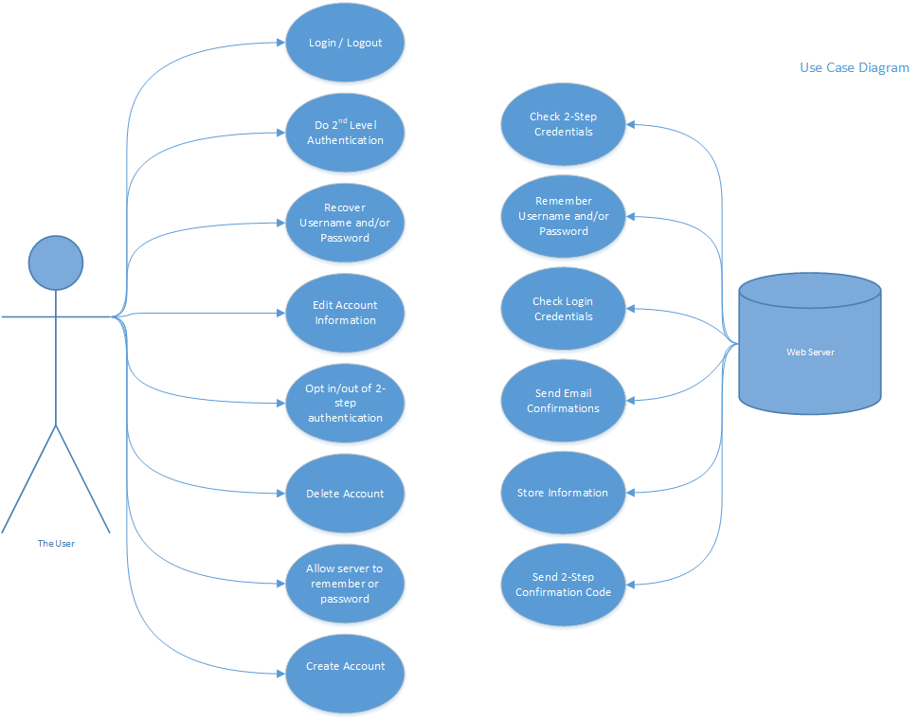

## Use Case List

|  |  |  |
| --- | --- | --- |
| **Use Case** | | |
| **Sequence Number** | **Actor** | **Goal** |
| 1 | User | Create Account |
| 2 | User | Login |
| 3 | User | Edit Account Info |
| 4 | User | Delete Account |
| 5 | User | Opt in/out of 2-step authentication |
| 6 | User | Do 2nd level authentication |
| 7 | User | Recover username or password |
| 8 | User | Allow server to remember username and password |
| 9 | Server | Check 2-step credentials |
| 10 | Server | Remember username and password |
| 11 | Server | Check login credentials |
| 12 | Server | Send email confirmations |
| 13 | Server | Store Information |
| 14 | Server | Send 2-step confirmation code |

+

### Create Account

Primary Actor: User

Secondary Actors(s): Web Server

Goal in Context: Create an account.

Preconditions: Have internet access, have access to an email address, use appropriate username and password.

### Login

Primary Actor: User

Secondary Actors(s): Web Server

Goal in Context: Login.

Preconditions: Have internet access, have access to an email address (for first time login or if 2-step verification is turned on).

### Edit Account Info

Primary Actor: User

Secondary Actors(s): Web Server

Goal in Context: Allow the user to edit account info.

Preconditions: Have internet access, have access to an email address.

#### Change Username

Allow the user to change their username.

#### Change Password

Allow the user to change their password.

#### Change Email

Allow the user to change their email.

### Delete Account

Primary Actor: User

Secondary Actors(s): Web Server

Goal in Context: Delete account.

Preconditions: Have internet access.

### Opt in/out of 2-step authentication

Primary Actor: User

Secondary Actors(s): Web Server

Goal in Context: Give user an option of having a 2-step authentication.

Preconditions: Have internet access, have access to an email address.

### Do 2nd Level Authentication

Primary Actor: User

Secondary Actors(s): Web Server

Goal in Context: Allow the user to enter the code sent to them via email to authenticate.

Preconditions: Have internet access, have access to an email address.

### Recover username or password

Primary Actor: User

Secondary Actors(s): Web Server

Goal in Context: Allow the user to be able to recover their username or password.

Preconditions: Have internet access, have access to an email address.

### Allow server to remember username and password

Primary Actor: User

Secondary Actors(s): Web Server

Goal in Context: Allow the server to remember username and password.

Preconditions: Have internet access.

### Check 2-step credentials

Primary Actor: Web Server

Secondary Actors(s): User

Goal in Context: The server will check if the code entered by the user matches the code sent to their email.

Preconditions: Server must be online.

### Remember username and password

Primary Actor: Web Server

Secondary Actors(s): User

Goal in Context: The server save the username and password for the user so that they don’t have to enter it when they login.

Preconditions: Server must be online.

### Check Login credentials

Primary Actor: Web Server

Secondary Actors(s): User

Goal in Context: The server will check if the username and password entered by the user match an account.

Preconditions: Server must be online.

### Send Email Confirmation

Primary Actor: Web Server

Secondary Actors(s): User

Goal in Context: The server will send a confirmation email to the email account associated with the logged in account.

Preconditions: Server must be online, user must have internet access and access to an email address.

### Store Information

Primary Actor: Web Server

Secondary Actors(s): User

Goal in Context: The server will store the account information of the user.

Preconditions: Server must be online.

### Send 2-step confirmation code

Primary Actor: Web Server

Secondary Actors(s): User

Goal in Context: The server will send an a code to the email associated with the logged in account.

Preconditions: Server must be online.